
A SYNOPSIS ON
Navratri Celebrations in Ahmedabad: Cultural Significance and Economic Impact

SUBMITTED BY
NAME: KHUSHI VATS
ENROLLMENT NO.: 2110178363
PTS-02

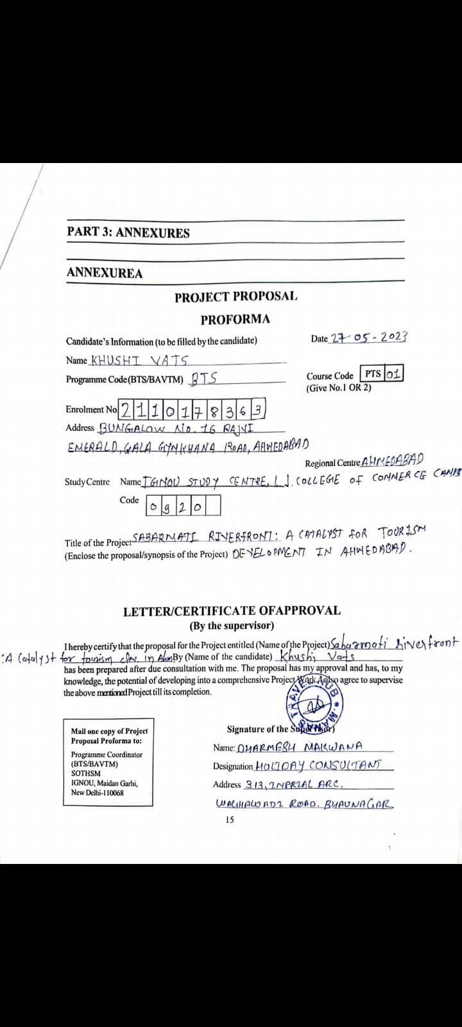
INTRODUCTION
Navratri, one of the most prominent and enthusiastically celebrated festivals across India, holds a place of particular reverence in the cultural heart of Ahmedabad. This festival, dedicated to the worship of the Hindu deity Durga, spans nine nights and is characterized by a series of rituals and the vibrant dance form known as Garba, which has its roots in Gujarat. In Ahmedabad, Navratri is not only a spiritual observance but also a major social and economic event that transforms the city into a hub of activity, drawing participants from across the globe.

The significance of Navratri in Ahmedabad extends beyond mere celebration. It encapsulates a complex amalgam of religious devotion, cultural identity, and economic opportunity. Each year, as the city decks itself in lights and colour, it welcomes thousands of visitors, both domestic and international, who come to partake in the festivities. These gatherings are not only a spectacle of cultural expression but also a potent catalyst for the local economy, boosting everything from small scale enterprises to larger hospitality and tourism sectors.

This study seeks to explore the multifaceted impacts of the Navratri festival on Ahmedabad, delving into how it serves as an anchor for cultural preservation amidst urban expansion, and acts as a driver of economic vitality. By weaving together the narratives of tradition and modernity, the research will illuminate the symbiotic relationship between Ahmedabad’s cultural heritage and its contemporary economic landscape during Navratri, offering insights into how the festival shapes and is shaped by the city's socio-economic dynamics.

Through this exploration, the project aims to provide a comprehensive understanding of Navratri's role in promoting cultural continuity while fostering economic growth, thus highlighting its significance as more than just a religious or cultural event, but as a pivotal economic phenomenon within the urban fabric of Ahmedabad.

This introduction sets the stage for a thorough analysis of both the cultural significance and economic impacts of Navratri in Ahmedabad, positioning the festival as a dynamic element of the city’s cultural and economic identity.

RATIONALE OF THE STUDY
Understanding the complex dynamics between cultural festivities and economic activities during Navratri in Ahmedabad provides essential insights for cultural economists, policymakers, and festival organizers. This study will explore how Navratri, as a major cultural event, contributes to the local economy while reinforcing cultural identity and community values in a rapidly urbanizing space.

OBJECTIVES OF THE STUDY
  - To analyze how Navratri supports and enriches local cultural traditions, focusing on rituals, music, dance (Garba and Dandiya), and attire.

  - To measure the direct and indirect economic impacts of Navratri on Ahmedabad’s economy, particularly on tourism, hospitality, retail, and local artisan sectors.

  - To gather detailed information about the demographics, preferences, and spending patterns of both domestic and international visitors during Navratri.

  - To evaluate existing marketing strategies and promotional activities used to attract tourists to the Navratri festival.

  - To identify and recommend sustainable practices that could be implemented to manage the environmental impact of the festival while promoting economic growth.

  - To provide strategic recommendations for local government, festival organizers, and businesses to enhance the cultural impact and economic benefits of Navratri.

RESEARCH METHODOLOGY
The research methodology for this study on the cultural significance and economic impact of Navratri in Ahmedabad will employ a mixed-methods approach. This approach integrates both qualitative and quantitative research methods to provide a comprehensive analysis of the festival’s effects. Below are the details of the research methodology:

TOOLS FOR DATA COLLECTION

Data Collection Methods:
- Surveys:
  - Participants: Tourists (both domestic and international), local residents, business owners, and festival organizers.
  - Purpose: To collect quantitative data on visitor demographics, spending patterns, business turnover during the festival, and overall satisfaction with the festival experience.
  - Distribution: Surveys will be distributed online prior to the festival and in person during Navratri at various event locations.

- Interviews:
  - Participants: Key informants including cultural experts, local government officials, festival committee members, and representatives from the tourism and hospitality sectors.
  - Purpose: To gather in-depth qualitative insights on the cultural significance of Navratri, the festival's management, marketing strategies, and perceived economic impacts.
  - Format: Semi-structured interviews will be conducted to allow for flexibility in responses and to explore complex topics in detail.

- Observational Studies:
  - Setting: Various Navratri event venues across Ahmedabad.
  - Purpose: To observe firsthand the cultural practices, visitor engagement, and operational aspects of the festival.
  - Technique: Non-participant observation will be used, where the researcher does not interact with the subjects but observes the natural flow of events during the festival.

Data Analysis Methods:
- Quantitative Analysis:
  - Tools: Statistical software (such as SPSS or R) will be used for data coding and analysis.
  - Techniques: Descriptive statistics, correlation analysis, and regression analysis to understand the relationships and impacts of various factors like visitor numbers on local economic outputs.
- Qualitative Analysis:
  - Tools: NVivo or ATLAS.ti for thematic analysis of interview transcripts and observational notes.
  - Techniques: Content analysis to identify recurring themes and narratives related to cultural significance and economic benefits, and to interpret the contextual meaning of data derived from qualitative research.

Ethical Considerations:
- Informed Consent: All participants in surveys and interviews will be informed about the purpose of the research and must provide consent to participate.
- Confidentiality: The identity of all respondents will be kept confidential, and data will be anonymized before analysis to ensure privacy.
- Transparency: Findings will be reported honestly, and any potential conflicts of interest will be disclosed in the research publication.

Validation:
- Triangulation: By using multiple data sources (surveys, interviews, and observations), the study will employ triangulation to cross-verify and strengthen the findings.
- Peer Review: Drafts of the study’s findings will be reviewed by peers and subject matter experts to ensure accuracy and credibility of the research.

CHAPTERIZATION
Chapter 1: Introduction - Introduces Navratri and its importance in Ahmedabad.
Chapter 2: Cultural Analysis - Explores the traditions and cultural practices associated with Navratri, including their origins and transformations.
Chapter 3: Economic Impact - Analyzes how Navratri influences the local economy, with a focus on specific sectors.
Chapter 4: Tourist Analysis - Studies the demographics, behaviour, and consumption patterns of tourists.
Chapter 5: Strategic Development - Proposes ways to optimize the festival's cultural and economic impacts.
Chapter 6: Conclusions and Recommendations - Summarizes findings and suggests directions for future research and festival planning.

REFERENCES
- Books and Scholarly Articles:
  - Anderson, B. (2009). Festivals and Cultural Identity: The Role of Celebration in Creating Community. London: Routledge.
  - Chatterjee, S., & Gupta, R. (2017). "Economic Impacts of Cultural Festivals: The Case of Diwali in Gujarat." Journal of Cultural Economics, 41(4), 487-504.
  - Kumar, A., & Singh, P. (2015). "Tourism and Cultural Festivals: Evidence from the Navratri Festival in Gujarat." Tourism Management, 49, 354-369.

- Reports and White Papers:
1. Gujarat Tourism Board. (2020). Economic Impact of Navratri on Gujarat’s Economy. Gandhinagar: Government of Gujarat.
- Patel, D. (2018). Navratri Festival: Strategies for Sustainable Tourism Development. Ahmedabad: Centre for Cultural Resources and Training.
- Conference Proceedings: 6. Mehta, V. (2019). "Cultural Festivals as Catalysts for Economic Development: Insights from Navratri." In Proceedings of the International Conference on Cultural Tourism (pp. 142-156). New Delhi: Tourism Research Association.
- Theses and Dissertations: Joshi, H. (2016). Impact of Traditional Festivals on Local Economies: A Case Study of Navratri in Ahmedabad (Master’s thesis). University of Gujarat, Ahmedabad.
- Online Sources: Ahmedabad Municipal Corporation. (2021). Navratri Celebrations and Public Safety Guidelines. Retrieved from https://www.ahmedabadcity.gov.in
- Singh, L. (2022). "Navratri's Impact on Local Businesses in Ahmedabad." Economic Times. Retrieved from https://www.economictimes.indiatimes.com/articles/navratri-impact-on-businesses
- Interviews and Personal Communications: 10. Sharma, R. (Interviewee). (2022, March 15). Interview on the Cultural Significance of Navratri in Ahmedabad. (A. Patel, Interviewer).
- Government Documents: 11. Ministry of Culture, India. (2019). Cultural Statistics of India 2019. New Delhi: Ministry of Culture.

